**Rose Blanket**

**Hook size**: 4mm

**Yarn**: Stylecraft Special DK 100g - Soft Peach (1 ball), Candyfloss (1 ball)

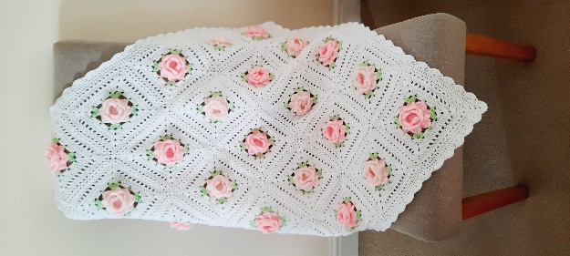White (3 balls) & Spring Green (1 ball).

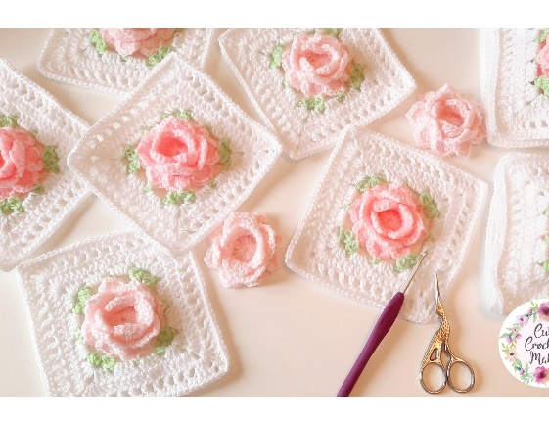**This pattern is written in US terms**

**US Terminology**                      **UK Terminology**

SC – single crochet                      DC

HDC – half double crochet HTR

DC – double crochet                    TR

MR – magic ring

ST - stitch

CH – chain

(  ) – indicate all stitches to be made in one stitch.

***PICOT*** *-* CH2, then SLST in the 1st CH made.

***3DCTOG*** - yarn over (YO), insert hook, pull up a loop, YO, pull through.( 2 loops on hook.) YO, insert hook, pull through, YO, pull through 2 loops. (3 loops on hook). YO, insert hook, YO, pull through 2 loops. YO pull through all 4 loops on hook.

The rose square is the same as the one used in Week 6 of the unicorns dreams blanket -

<https://cutecrochetmakes.wixsite.com/cutecrochetmakes/unicorn-blanket-cal>

There is also a YouTube video of my rose square available on week 6.

I made 13 of the candyfloss rose squares and 12 of the soft peach rose squares. My blanket measured 80cm x80cm. If you wanted to make a larger/ smaller blanket just add more/less squares.

1. Using **CANDYFLOSS** in a MR make 16DC. SLST in 1st DC to join. (16 stitches).
2. (CH1 – *does not count as ST here or throughout pattern* ,SC), **\*** CH3, Skip 1 ST, SC in next ST. Repeat from **\*** around. SLST in the 1st SC made to join. (8 Chain spaces).
3. (SLST into CH space, SC), **\*** 6DC in the next CH space. SC in the next CH space Repeat from **\*** around, finishing with a SLST in the 1st SC made. ( 4 petals made).
4. CH1, **TURN flower around**. **\*** SC around SC post from row 2, CH3. Repeat from **\*** around. SLST into 1st SC made to join. (8 CH3 spaces made).
5. CH1, Turn flower around. Working on the **RIGHT** side, Make **\*** (4DC, PICOT, 4DC) around CH space, SC in next CH space. Repeat from **\*** around. SLST in top of 1st DC made to join. (4 petals made).
6. CH2, **Turn flower over**. Work **\*** SC around SC post from round 4 .CH3. Repeat from **\*** around. SLST in the 1st SC made to join. (8 CH3 spaces made).
7. CH1, **Turn** flower around, with **RIGHT** side facing, make (SC, 3DC, PICOT, 3DC, SC) in each CH space. Finish with a SLST in beginning SC to join. (8 petals made). Fasten off yarn.
8. ***Leaves*** – join **SPRING GREEN** in the PICOT space. (CH3 *– counts as the 1st DC of the 3DC2TOG,* 2DCTOG, CH5, 3DCTOG), **\*** CH5, (SC in picot of next petal, CH5, (3DCTOG, CH5, 3DCTOG) in next petal picot. Repeat from **\*** around. SLST in top of 1st 3DCTOG made to join. Fasten off. (8 leaves made).
9. Using **WHITE** join in CH5 space between 2 petals. (CH5, 3DC). Make **\***4DC around CH5, 4DC around next CH5. (3DC, CH2, 3DC) in between the next set of leaves. Repeat from **\*** around finishing in between the 1st set of leaves with a 2DC and SLST in the 3rd CH of the beginning CH5. (64 stitches).
10. SLST into the corner CH2 space. (CH5, 2DC). **\*** DC in every ST across. Make (3DC, CH2, 3DC) in the next corner space. Repeat from **\*** around finishing in the beginning corner space with (2DC, CH2) and SLST into the 3rd CH of the beginning CH5 to join. (88 stitches).
11. SLST into the corner CH 2 space. (CH5, 2DC). Skip the 1st 2sts. DC, in next ST. **\*** CH1, skip 1ST , DC. Repeat from **\*** around and make (3DC, CH2, 3DC) in each corner space. Always miss 2sts after corner, making the 1st DC in the 3rd ST from corner). Finish in the beginning corner with (2DC, CH2) and SLST into the 3rd CH of the beginning CH5 to join. (108 stitches, each row has 15DC).
12. SLST into the corner CH2 space. (CH1, SC). **\*** SC in each ST and CH space around with (SC, CH2, SC) in the corner. Repeat from **\*** around finishing in the beginning CH2 space with a SC, CH2 and SLST into the 1st SC made to join. (116 stitches. each side has 27SC with CH2 in between).

I used the flat braid join to join all the squares together. This can also be found with a YouTube tutorial under week 8 of the unicorn dreams blanket.

1. Join the ​**WHITE** ​yarn in the corner CH space (SC, CH3, SC). CH3 **\*** Skip the next ST and make a SC in the following ST – *the 2nd ST across*. CH3. Repeat from **\*** finishing with CH3 a skipped ST before the next corner space. In the corner space make (SC, CH3, SC). *There will be 15 CH3 loop spaces across, in-between the corners (This will be the same for each side of the squares).*
2. Working down the side of the square, **\*** CH3, skip the 1st ST. SC in the next ST. Repeat from **\*** until you finish with a CH3 and the skipped ST before the next corner CH space. (13 CH3 loops made).SC in the corner space, **CH5**.
3. *Joining the next square.* SC into the bottom CH- space on the next square. CH3. **REMOVE** the hook and place under the last CH3 loop on the 1st square. Grab the loop and pull through. CH3. Skip a ST on the 2nd square and SC into the next ST. **\*** CH1. Remove hook. Place hook under the next CH3 on the 1st square. Grab loop and pull though. CH2. Skip a ST on the 2nd square and SC into the next ST. Repeat from **\*** working through all 13 loops up the side of square until you finish with a CH3 and the skipped ST before the next corner CH space. SC in the CH-space of the 2nd square. CH3. Remove the hook, place under the CH3 loop in the 1st square’s corner space. Grab loop and pull though. CH3 and SC back in the corner CH space on the 2nd square.
4. CH3 and Repeat from Row 1 **\*** to join the next 3 squares together. At the end of the row, you will have 5 squares joined and finish in the corner left CH space with (SC, CH3, SC). CH3, skip the 1st ST. SC in the next ST. Repeat this across until you finish with a CH3 and the skipped ST before the next corner CH space. SC into the Corner CH- space. CH3. Remove hook, Place hook from back to front under the CH5 loop, grab loop and pull through. CH3 and SC into the next CH- space on the next square.

